PAC-Poly-Tahiti-Mortuary Scene 1786 John Webber TAHITI Tupapau--COOK-1786

## View of the house or shed called a Tupapow in Otaheite under which the dead are deposited with a representation of the peculiar dress of the principal mourner and a man climbing on the bread fruit tree to get out of the way

32 cm x 21 cm copperplate engraving, 35.5 cm x 23.5 cm sheet size, modern hand colour, Alexander Hogg, London, 1784-1786

We are pleased to offer this scarce and historically important original fine art engraving after an original drawing by the [*HMS Endeavour*](http://en.wikipedia.org/wiki/HMS_Endeavour)ship's artist [Sydney Parkinson](http://en.wikipedia.org/wiki/Sydney_Parkinson) (1745-1771) depicting the funeral rituals and an open air burial platform here attended by the "Chief Mourner" clad in his aureole headdress of feathers and breast gorget of mother-of-pearl. Sadly, Parkinson did not survive the voyage, dying of dysentery and malaria after departing Batavia but left behind over 900 sketches and drawings and some 280 botanical paintings as primary visual sources.  The plate was engraved for the *New, Authentic, Entertaining, Instructive, Full and Complete Historical Account of Captain Cook's First, Second, Third and Last Voyages*[1](http://vi.vipr.ebaydesc.com/ws/eBayISAPI.dll?ViewItemDescV4&item=261788914047&t=1424300042000&tid=10&category=360&seller=regiomontanus&excSoj=1&excTrk=1&lsite=0&ittenable=false&domain=ebay.com&descgauge=1" \l "1) published serially between 1784 and 1786.  Cook explains in his journal why the man climbed the breadfruit tree to avoid the Chief Mourner:

"One part of the ceremony, however, which accounts for the running away of the people as soon as this procession is in sight, has not been mentioned. The chief mourner carries in his hand a long flat stick, the edge of which is set with shark's teeth, and in a phrenzy, which his grief is supposed to have inspired, he runs at ail he sees, and if any of them happen to be overtaken, he strikes them most unmercifully with his indented cudgel, which cannot fail to wound them in a dangerous manner."2

A historically important image of Pacific illustration, this strong imprint is enhanced by finely executed hand colour work and will make an elegant presentation if matted and framed and an important addition to any collection related to Tahiti  or the voyages of James Cook.

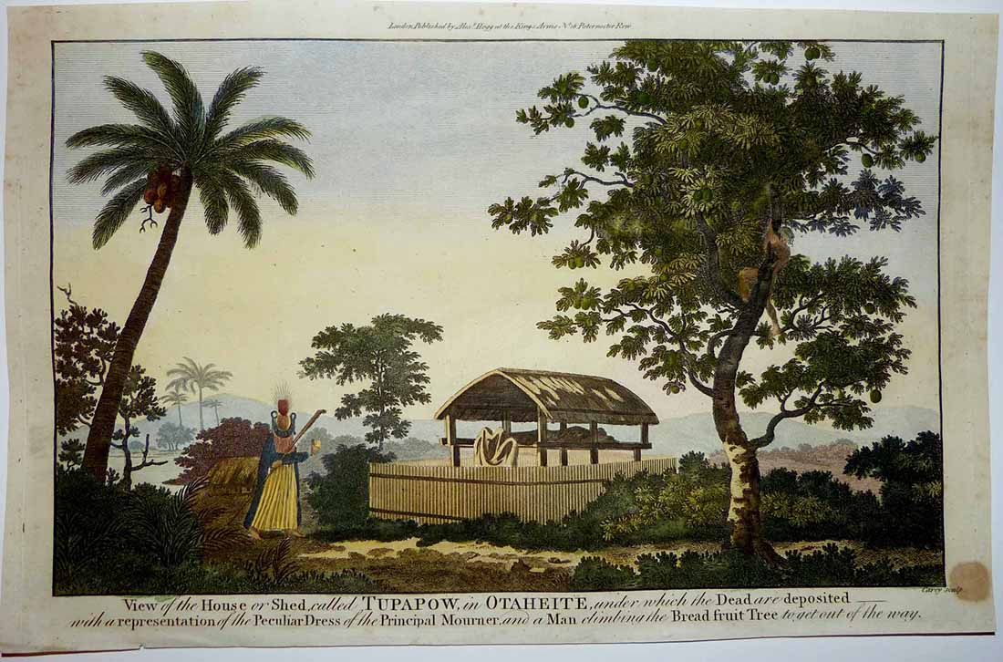

Parkinson drew several studies of these burial sites during his stay in Tahiti, and this image was actually developed from Parkinson's original by the Irish artist [John James Barralet](http://en.wikipedia.org/wiki/John_James_Barralet) (1747-1815) in 1773 in preparation for engraving.  To get a sense of print detail consider that the Chief Mourner stands just 5 cm tall actual size:

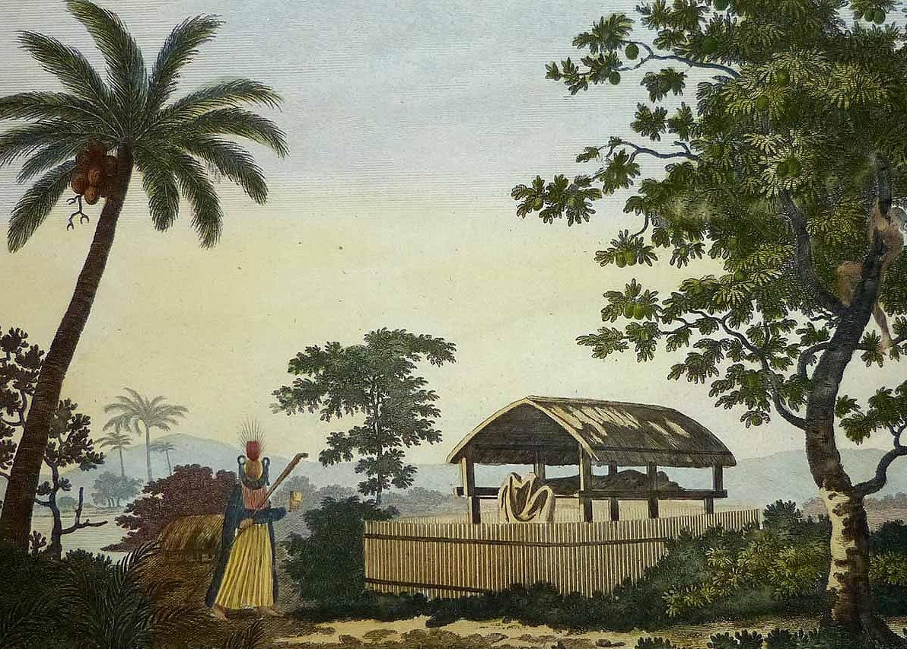

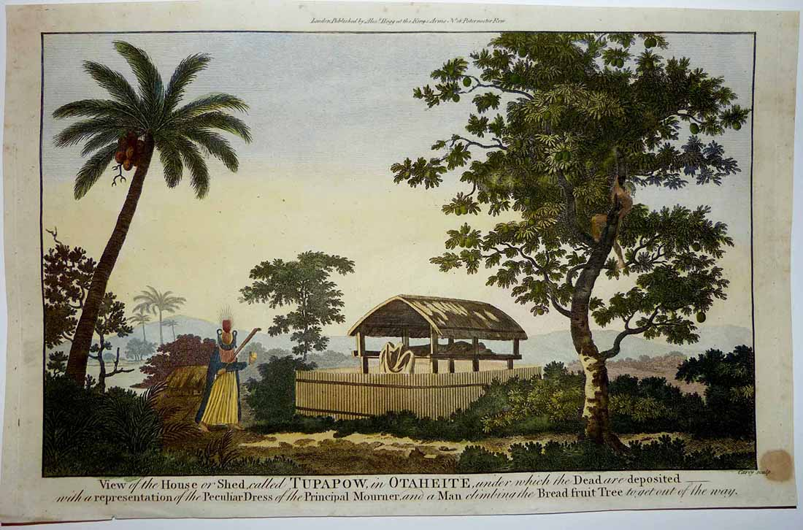

Condition - Please note carefully:  The print is in overall very good condition as can be evaluated in photos, other than a few tiny "as issued" spots in paper the image area is essentially pristine, no text on verso, no folds, strong impresssion on fine quality laid paper, excellent hand colour work, one ~ 15 mm diameter spot in lower right corner margin, trivial soiling to margin extremities, small chip to lower margin edge.  Image of print shows it lying flat in free state with all edges shown for evaluation.  [Inquiries](mailto:jfazli@ix.netcom.com) welcome and we encourage you to visit our other [listings](http://cgi6.ebay.com/aw-cgi/eBayISAPI.dll?ViewListedItems&userid=regiomontanus&sort=3&since=-1) on eBay.  
  
NOTES:  
  
1. The editor of the *New, Authentic, Entertaining, Instructive, Full and Complete Historical Account of Captain Cook's First, Second, Third and Last Voyages* was named as one "George William Anderson",  almost certainly a pseudonym for the publisher Alexander Hogg.  In a recent exhibition of these historically important engravings made for this publication the Lowe Art Museum in Miami noted that the pseudonym was "a device Hogg employed in a number of his publications" intended to convey an "aura of authoritative knowledge" regarding his editing of the official publications of the voyages.  Hogg shrewdly elected to publish the work (which eventually included accounts of other circumnavigations) in a relatively affordable serial format from 1784-1786 to reach a broad audience, noting in his marketing copy that this was "due to the many thousands of Persons who would wish to peruse the Discoveries... and view the astonishing fine Copper-Plates, who have hitherto been excluded from gratifying their eager curiosity.  These installments would allow every Person, whatever may be his Circumstances, to read about the voyages of which such vast Sums of the Public Money have been expended."  
   
2.  Cook, James. *A Voyage Towards the South Pole and Round the World: Performed in His Majesty’s Ships the Resolution and Adventure, in the Years 1772, 1773, 1774 and 1775*. 1st ed. 2 vols. London, 1777